Part time evaluation exam

Create a module of product manufacturer system where Magento will manage a list of manufacturers. Each product is produced by only one manufacturer.

Manufacturer entity table:

**manufacturer_entity**

|  |  |  |
| --- | --- | --- |
| **Field name** | **Data type** | **Extra** |
| entity_id | INT | NOT NULL, PRIMARY, AUTO_INCREMENT |
| name | varchar(255) |  |
| enabled | int(1) |  |
| address_street | varchar(255) |  |
| address_city | varchar(100) |  |
| address_country | varchar(5) |  |
| contact_name | varchar(100) |  |
| contact_phone | varchar(20) |  |

## Database schema and models

* Create the above table when the module is installed
* Create model for the manufacturer entity

## Controllers and forms

* Create a html form where the admin can input new manufacturer information. A list right below should show all available manufacturers

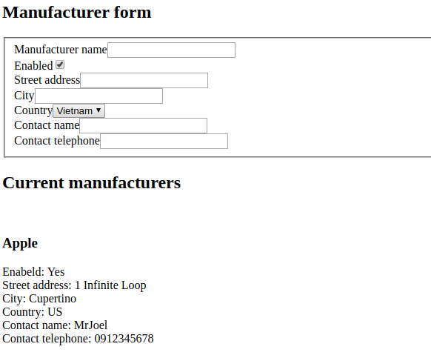

* Create a save controller where the form post value can be saved

**\* If you could not save form in this question, input information into the database manually to proceed to later questions**

## EAV and Product attributes

* Create a new product attribute named **manufacturer_id** (type int).

The attribute should be displayed in product backend edit page as a select field, where all enabled manufacturers are displayed and can be chosen

When the product is saved, the entity_id of the manufacturer will be saved into the product attribute

## HTML, Styling and Javascript

* Display manufacturer name on frontend product detail page

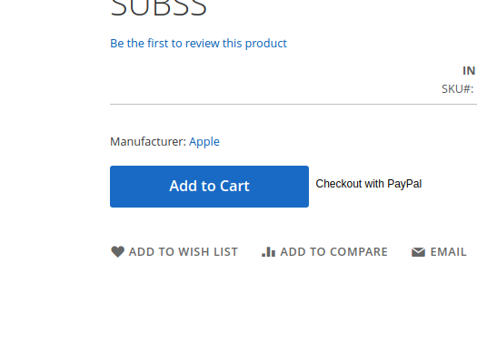

* Display an alert when clicking on the manufacturer’s name

